––SnapClass: A Dual-Modality AI Attendance System Using Facial and Voice Recognition
Tirtho Mojumdar, Ramisa Anjum, Md Rakibul Hasan, and Hafsa Amin Ela
Department of Electrical and Computer Engineering, North South University, Dhaka, Bangladesh
Abstract—
Manual attendance-taking in university classrooms is time-consuming, disruptive to instruction, and vulnerable to proxy attendance. This paper presents SnapClass, a web-based attendance system that automates roll-taking using two independent biometric modalities: facial recognition and voice (speaker) recognition. Faces are localized with a Histogram-of-Oriented-Gradients detector, encoded into 128-dimensional embeddings using a deep residual network, and classified against enrolled students with a support-vector machine, followed by a Euclidean-distance sanity check to reject unenrolled individuals. Voice samples are segmented with an energy-based voice-activity detector and encoded into speaker embeddings using a generalized end-to-end (GE2E) trained encoder, matched via cosine similarity. Both pipelines feed a mandatory human-in-the-loop review step before any attendance record is written to the cloud database, so automated predictions never silently determine a student's attendance. The system is implemented with a Streamlit front end and a Supabase (PostgreSQL) backend, and supports separate teacher and student roles, subject creation and enrollment via QR code, and historical attendance reporting. Informal functional testing across multiple sessions showed that the face pipeline reliably rejected individuals absent from the enrolled dataset, while recognition accuracy for enrolled individuals was sensitive to the number of enrollment samples and to lighting conditions; the voice pipeline performed reliably under quiet conditions but degraded with background noise. We discuss these observations, the system's limitations, and directions for formal large-scale evaluation.
Index Terms—Face recognition, speaker verification, biometric attendance, support vector machine, d-vector, human-in-the-loop AI, Streamlit, Supabase, classroom automation.

I. INTRODUCTION
Attendance tracking is a routine but non-trivial administrative task in higher education. Traditional roll-call or sign-in-sheet methods consume valuable class time, are prone to human error in large sections, and are susceptible to a student signing in on behalf of an absent peer. As webcams, microphones, and cloud infrastructure have become standard on nearly every device used in a classroom, biometric attendance verification has become a practical alternative to paper-based methods, without requiring dedicated fingerprint or RFID hardware.
The problem is compounded in large sections, where a single roll call by name can consume five to ten minutes of instructional time per class meeting, and where an instructor has little practical ability to verify that the student answering to a name is actually present in the room. Digital sign-in sheets and learning-management-system check-ins reduce the time cost but do not address impersonation, since they still rely on a student entering a peer's information on their behalf. This project, SnapClass, explores whether a lightweight, browser-based application can combine two independent and complementary biometric signals — a student's face and a student's voice — into a single attendance workflow that a course instructor can operate from an ordinary laptop. Rather than fully automating attendance decisions, the system is deliberately designed around a human-in-the-loop principle: every attendance record produced by either recognition pipeline is presented to the teacher for review before it is committed to the database, reducing the risk that a misclassification silently affects a student's academic record.
The main contributions of this work are:
• Design and implementation of an integrated face-and-voice biometric attendance pipeline usable with only a standard webcam and microphone.
• A cloud-connected, role-based web application (teacher and student portals) supporting subject creation, QR-code-based enrollment, and attendance history.
• A mandatory human-confirmation step that separates automated recognition from the final attendance decision.
• An informal empirical evaluation that surfaces practical strengths and weaknesses of small-sample biometric enrollment in a real classroom setting.
The remainder of this paper is organized as follows. Section II reviews related work on face- and voice-based recognition and positions our contribution relative to it. Section III describes the overall system architecture. Section IV details the methodology behind each recognition pipeline and the application workflow. Section V discusses implementation choices. Section VI reports informal testing results. Section VII discusses limitations and future work, and Section VII concludes the paper.
A. Problem Statement and Requirements
A useful classroom attendance system must satisfy requirements beyond raw recognition accuracy: it must be operable by a non-technical instructor within the first few minutes of class, must not require specialized hardware beyond what is already present on a laptop or phone, must keep an auditable historical record per subject, and must not allow an automated misclassification to silently alter a student's record. Table I summarizes the functional and non-functional requirements that guided the design of SnapClass.
TABLE 1
FUNCTIONAL AND NON-FUNCTIONAL REQUIREMENTS
ID | Requirement
FR1 | Teachers can register, log in, and create/manage subjects.
FR2 | Students can enroll a biometric profile (face, optional voice) and log in via face recognition.
FR3 | Students can join a subject via a shared code or scanned QR image.
FR4 | Teachers can capture classroom photos or audio and run automated recognition.
FR5 | All automated results must be reviewed and explicitly confirmed before being saved.
FR6 | Teachers and students can view historical attendance records.
NFR1 | The system must run in a standard web browser with no client installation.
NFR2 | Recognition must complete within a few seconds to remain usable in class.
NFR3 | Passwords must never be stored in plaintext.

II. RELATED WORK
A. Face-Recognition-Based Attendance
Automated face recognition for attendance has been studied extensively; most classroom systems rely on classical detectors combined with learned embeddings rather than end-to-end deep pipelines, owing to limited enrollment data per class. The dlib library [1] provides both a Histogram-of-Oriented-Gradients face detector and a residual-network face-recognition model trained with a triplet-loss objective conceptually similar to FaceNet [2], producing a 128-dimensional embedding in which Euclidean distance approximates facial similarity. Because only a handful of labeled images are typically available per student, prior classroom systems commonly pair such embeddings with a lightweight classical classifier — most often a support-vector machine [3] — rather than retraining a deep network per class. This combination trades a small amount of theoretical accuracy for practicality: an SVM can be retrained on a laptop in well under a second even as new students enroll mid-semester, which is not true of fine-tuning a deep network.
B. Speaker Verification for Voice-Based Identification
For the voice modality, speaker verification has moved from hand-crafted MFCC features toward learned speaker embeddings (d-vectors) optimized with generalized end-to-end loss [4], which we use via the open-source Resemblyzer encoder. Voice-activity detection to isolate spoken segments from raw audio is performed with librosa [5], a widely used Python audio-analysis library. Voice-based identification is comparatively underused in classroom attendance literature relative to face recognition, despite requiring only a microphone and offering a natural fallback when a student's face is occluded (e.g., by a mask) or poorly lit.
C. Human-in-the-Loop System Design
Beyond attendance specifically, our design follows general guidance for human-AI interaction, which recommends that an automated system make its uncertainty and its reasoning visible to the human operator and give that operator an easy way to correct mistakes before they take effect [10]. The review-and-confirm dialog described in Section IV-C is a direct application of this principle: rather than exposing a raw confidence score to the teacher, the system exposes the concrete evidence (which photo or audio segment triggered a match) and requires an explicit accept/reject action.
D. Positioning of This Work
Unlike systems that rely on a single modality and commit results automatically, SnapClass combines both modalities behind a shared human-confirmation step, and targets deployment on commodity hardware through a browser rather than a dedicated kiosk or embedded device. This positions the system closer to a decision-support tool for the instructor than a fully autonomous identification system, which we argue is the more responsible design point for a system that affects a student's academic record.
E. Comparison with QR-Code and App-Based Check-In
A simpler alternative to biometric recognition is a QR-code or mobile-app check-in, where each student scans a code displayed by the instructor or taps a button inside a learning-management-system app. Such systems are inexpensive to build and avoid biometric privacy concerns entirely, but they reintroduce the impersonation problem this project is motivated by: a student can check in on behalf of an absent classmate simply by using that classmate's phone or account. SnapClass already uses QR codes, but only for the lower-stakes task of joining a subject roster, while the higher-stakes attendance decision itself is left to biometric matching combined with teacher review, which we view as a more defensible division of responsibility between convenience and verification.
Non-biometric alternatives such as RFID cards or barcode scanning remove ambiguity about identity matching but require distributing and maintaining physical tokens, and do nothing to prevent a student from carrying a classmate's card. Fingerprint scanners avoid the token-sharing problem but require dedicated hardware at the classroom door and do not scale to large lecture halls where a queue would consume significant class time. Camera- and microphone-based recognition instead reuses hardware most students and instructors already carry, at the cost of being more sensitive to environmental conditions such as lighting and ambient noise — a trade-off this project's testing (Section VI) makes concrete rather than assumes away.

III. SYSTEM ARCHITECTURE
SnapClass follows a three-tier architecture, shown in Fig. 1. The client layer runs entirely in the browser, capturing webcam photographs and microphone audio through Streamlit's native input widgets and rendering role-specific screens for students and teachers. The application layer, implemented in Python, hosts the recognition pipelines (face and voice), a database-access layer, and a session-state-driven router that determines which screen to render based on the logged-in role and the user's navigation choices, since the application is a single page rather than a conventional multi-page site. The data layer is a hosted Supabase project, providing a managed PostgreSQL database accessed through a REST-like client library.
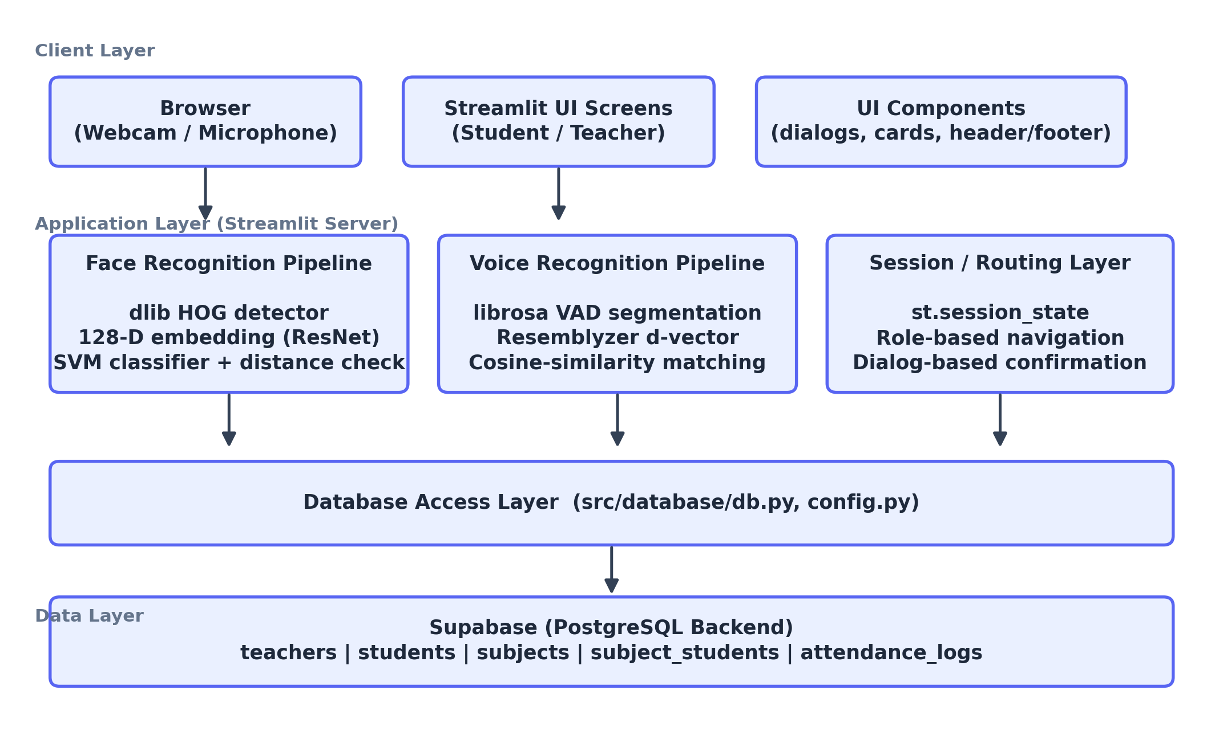
Fig. 1. Three-tier system architecture of SnapClass.

The relational schema consists of five tables: teachers, students, subjects, subject_students (a many-to-many enrollment join table), and attendance_logs. Face and voice embeddings are stored directly as vector-valued columns on the students table, avoiding the need for a separate vector database given the expected class-sized (tens to low-hundreds of rows) scale of the deployment.
SnapClass is deployed as a single Streamlit application connected to a hosted Supabase project, so no server administration is required beyond configuring environment secrets; database credentials are supplied through Streamlit's secrets manager rather than committed to source control. Because Streamlit serves each active session from a single Python process, the deployment model is best suited to one class session being actively processed at a time, which matches the intended single-classroom use case; supporting many simultaneous classroom sessions would require moving the recognition pipelines behind a horizontally scalable API rather than running them inline with the UI process.

IV. METHODOLOGY
A. Facial Recognition Pipeline
Given a captured image, faces are first localized using dlib's frontal HOG detector. For each detected face, 68 facial landmarks are located with a shape-predictor model, which are used to align the face before a pretrained residual network computes a 128-dimensional descriptor. Formally, the encoder can be viewed as a mapping
f : ℝ^{H×W×3} → ℝ¹²⁸ (1)
from a cropped face image to an embedding vector such that the Euclidean distance between embeddings of the same individual is small and the distance between embeddings of different individuals is large. Enrolled students' embeddings, together with their student IDs, are used to train a support-vector classifier with a linear kernel and balanced class weights each time a new student registers:
clf = SVC(kernel = ‘linear’, probability = True, class_weight = ‘balanced’).
At inference time, every detected face embedding x is classified by the SVM to obtain a predicted student identity, and the predicted identity's stored embedding xᵢ is retrieved for a secondary verification check:
d(x, xᵢ) = ‖x − xᵢ‖₂ (2)
A prediction is accepted only when d(x, xᵢ) ≤ τ, with τ = 0.6 in the current implementation. This secondary check exists because a linear SVM will always output some class label even for a face it has never seen, so the distance threshold acts as an explicit rejection mechanism for individuals outside the enrolled roster.
B. Voice Recognition Pipeline
Recorded classroom audio is resampled to 16 kHz and segmented using an energy-based voice-activity detector (librosa.effects.split with a 30 dB silence threshold), discarding segments shorter than 0.5 s to avoid encoding noise bursts. Each remaining segment is passed through a pretrained speaker encoder (Resemblyzer), trained with a generalized end-to-end loss over many speakers, to obtain a fixed-length speaker embedding. A candidate segment embedding e is compared against every enrolled student's stored voice embedding eᵢ using cosine similarity:
sim(e, eᵢ) = (e · eᵢ) / (‖e‖ ‖eᵢ‖) (3)
The enrolled student with the highest similarity score is selected as the identified speaker only if that score exceeds a threshold τᵥ = 0.65; otherwise the segment is left unmatched. Because a single audio recording may contain several students speaking in sequence, the pipeline processes all detected segments and accumulates the highest-confidence match per student across the whole recording.
C. Application Workflow
Fig. 2 summarizes the end-to-end attendance workflow shared by both modalities. A teacher initiates a session by capturing classroom photographs or a classroom audio recording for a selected subject. The corresponding recognition pipeline runs against all students enrolled in that subject, producing a per-student present/absent verdict together with the source photo or similarity score that justified it. Crucially, this result is never written directly to the database: it is first rendered in a review dialog, and only a teacher's explicit “Confirm & Save” action commits the corresponding rows to the attendance_logs table. A “Discard” action clears the pending result without any database write.
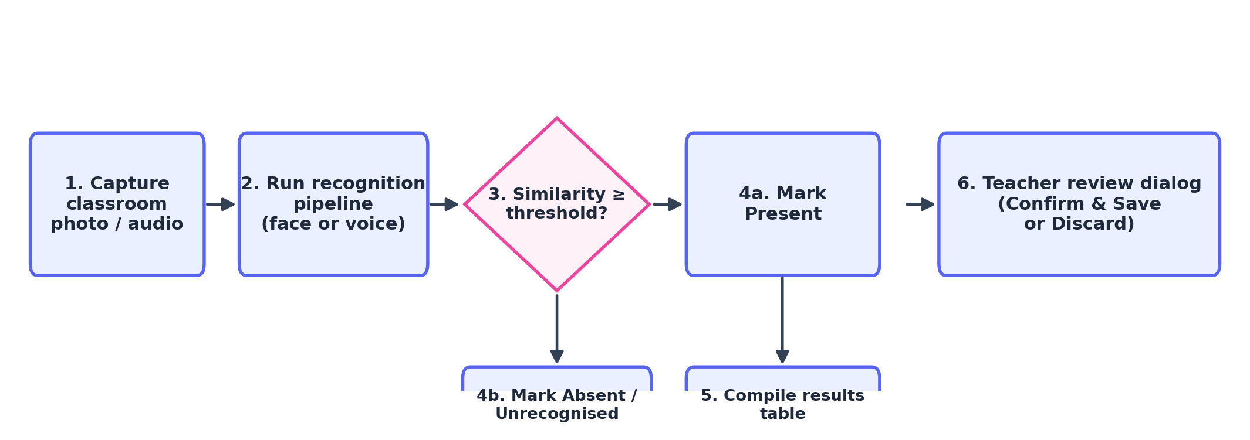
Fig. 2. Attendance-capture workflow, shared by the face and voice pipelines.

The student side of the application follows a related but distinct flow, shown in Fig. 3: a student presents their face to log in, and only if no match is found is the student prompted to register a new profile, with voice enrollment offered as an optional second step.
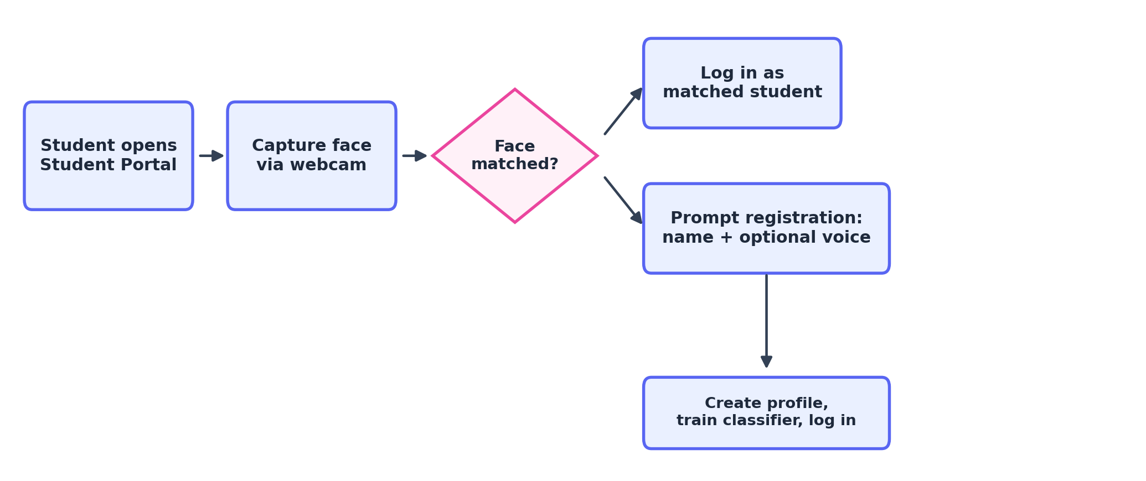
Fig. 3. Student face-ID login and first-time registration flow.

As a concrete illustration, consider a teacher who has created a subject and enrolled twenty students. At the start of a class, the teacher opens the attendance tab, selects the subject, and captures two or three photos spanning the room. The face pipeline runs automatically on submission, producing a per-student verdict together with the cropped face image that justified each match. The review dialog lists any enrolled students who were not matched in a separate, visually distinct group so the teacher can quickly re-capture a photo or manually adjust a record before confirming. Once confirmed, the twenty attendance rows are written to attendance_logs in a single batch, and the updated record is immediately visible to each student in their own history view.
D. Data Management
Table II summarizes the five relational tables that make up the Supabase schema and the fields most relevant to the recognition and reporting workflow.

TABLE 2
DATABASE SCHEMA OVERVIEW
Table | Key Fields | Purpose
teachers | username, password_hash, name | Teacher accounts
students | name, face_embedding, voice_embedding | Biometric profiles
subjects | subject_code, name, section, teacher_id | Course sections
subject_students | student_id, subject_id | Enrollment (M:N)
attendance_logs | student_id, subject_id, timestamp, is_present | Attendance history

Teacher passwords are hashed with bcrypt [6] before storage; no plaintext password is ever persisted. Attendance queries aggregate attendance_logs by session timestamp to compute per-class present/total counts for the teacher-facing reporting tab, and by student ID for the student-facing attendance history view. For a given subject, the displayed attendance rate for a student is computed as
R = (P / T) × 100% (4)
where P is the number of sessions in which the student was marked present and T is the total number of recorded sessions for that subject.
E. Scalability Considerations
Because the SVM classifier is retrained on the full set of enrolled embeddings each time a student registers, training cost grows with roster size; for a linear-kernel SVM this is manageable for the tens-to-low-hundreds of students typical of a single course section, but would become a bottleneck if the same classifier were shared across an entire institution. Likewise, voice matching in the current implementation performs a linear scan of cosine similarities against every enrolled student in a subject, which is adequate at class scale but would benefit from an approximate nearest-neighbor at larger scale. Both pipelines were designed around the class-section scale that Supabase's free tier and Streamlit's single-process deployment model comfortably support.
F. Recognition Hyperparameters
Table III lists the key thresholds and parameters used by the two recognition pipelines, all of which were set to conservative literature-typical defaults rather than tuned against a labeled validation set, consistent with the informal nature of the evaluation in Section VI.

TABLE 3
RECOGNITION PIPELINE HYPERPARAMETERS
Parameter | Value
Face embedding dimension | 128
Face distance threshold τ | 0.6 (Euclidean)
SVM kernel | Linear, class_weight = balanced
Voice sample rate | 16 kHz
VAD silence threshold | 30 dB
Minimum voice segment length | 0.5 s
Voice similarity threshold τᵥ | 0.65 (cosine)

V. IMPLEMENTATION
The complete stack was chosen to minimize deployment overhead while remaining capable of running both machine-learning pipelines inside a single Python process. Table IV lists the primary technologies used in each layer of the system.

TABLE 4
TECHNOLOGY STACK
Layer | Technologies
Front end / UI | Streamlit, PIL/Pillow
Face recognition | dlib, face_recognition_models, scikit-learn, NumPy
Voice recognition | librosa, Resemblyzer, PyTorch
Backend / storage | Supabase (PostgreSQL), bcrypt
Utilities | segno (QR-code generation), pandas

The application is organized into three internal layers mirroring Fig. 1: screens (home, teacher, student), reusable components (dialogs for creating subjects, enrolling students, capturing photos, and reviewing attendance results), and pipelines (face_pipeline.py, voice_pipeline.py) that isolate all machine-learning logic from the user interface. Streamlit's st.cache_resource decorator is used to load the face-detection models and the trained SVM classifier once per server process rather than on every interaction, and the classifier is explicitly retrained whenever a new student is registered. Subject sharing is implemented by encoding a joinable URL and subject code into a QR image with segno, which a student can scan to auto-enroll. Table V lists the primary screens and dialog components that make up the user interface.

TABLE 5
APPLICATION SCREENS AND DIALOG COMPONENTS
Component | Responsibility
Home screen | Role selection (student / teacher)
Teacher screen | Login/register; tabs for attendance, subjects, records
Student screen | Face-ID login; profile registration
Add-photo dialog | Camera capture or file upload for a session
Create-subject dialog | New subject code, name, section entry
Share-subject dialog | QR code and join-link generation
Enroll / auto-enroll dialogs | Join a subject by code or QR scan
Attendance-results dialog | Human review, Confirm & Save / Discard
Voice-attendance dialog | Audio capture and voice-based review

From a security standpoint, the review-and-confirm step described in Section IV-C is the system's primary safeguard against recognition errors, since it guarantees a human decision point before any record affects a student's attendance history.
B. Development Process
The codebase was developed collaboratively using Git and GitHub, with feature work merged into the main branch after the team reviewed the change together. This made it possible for different members to work on the face pipeline, the voice pipeline, and the user-interface components in parallel without repeatedly conflicting over the same files, and gave the team a point-in-time history to fall back on when a change needed to be reverted during integration testing.
C. Reproducibility
The complete source code, including both recognition pipelines, the Streamlit screens and dialog components, and the requirements.txt dependency list needed to reproduce the development environment, is available in the project's GitHub repository. Reproducing the results in Section VI requires only a webcam- or file-based photo, a microphone-recorded audio clip, and a configured Supabase project; no proprietary dataset or paid service beyond Supabase's free tier is required.

VI. RESULTS AND TESTING
A. Testing Methodology
Because SnapClass was developed and tested by the four-member project team rather than deployed to a live class section, the results reported here come from repeated, informal functional testing rather than a statistically powered evaluation on an independent dataset. Each of the four group members enrolled one face profile from a single reference photo and one voice profile from a short spoken phrase. The group then carried out several rounds of attendance capture, each round repeated three to five times, at different times of day, under different indoor lighting, summarized in Table VI. In addition to the enrolled members, at least one non-enrolled individual was included in face-recognition trials specifically to observe whether the system would incorrectly assign that person an enrolled identity.

TABLE 6
SUMMARY OF INFORMAL TEST ROUNDS
Rnd | Mod. | Condition | Outcome
1 | Face | Consistent lighting, enrolled members only | Recognized correctly, most trials
2 | Face | Non-enrolled individuals included | Reported “not recognized”, most trials
3 | Face | Lighting differs from enrollment photo | Occasional missed / low confidence
4 | Voice | Quiet room, enrolled phrase | Identified correctly, most trials
5 | Voice | Background noise / overlap | Reduced reliability
B. Face Recognition Observations
For the face pipeline, the distance-based rejection check (2) worked as intended: when the group deliberately tested with people who were not part of the enrolled dataset, the system consistently reported them as unrecognized rather than misassigning them to an enrolled student's identity, confirming that the secondary threshold check is an effective safeguard against the SVM's tendency to always output some class label. At the same time, because each student was enrolled with only a single reference photograph, the decision boundary learned by the SVM had limited data to generalize from, and occasional false negatives were observed for enrolled members when the test lighting or camera angle differed noticeably from the enrollment photo.
C. Voice Recognition Observations
For the voice pipeline, identification was reliable when audio was recorded in a quiet room with a single speaker per segment, consistent with the moderately conservative cosine-similarity threshold (τᵥ = 0.65). Reliability dropped when segments contained background classroom noise or overlapping speech from multiple students, since the voice-activity detector's fixed 30 dB threshold does not distinguish between the target speaker and ambient noise as robustly as a learned voice-activity model would.
D. Threats to Validity
The most significant threat to the validity of these observations is sample size: with only four enrolled individuals and a small number of test rounds, the results cannot be extrapolated to a full class section with different lighting fixtures, camera hardware, and voice characteristics. We emphasize that these observations are qualitative and were not derived from a held-out dataset with independent ground-truth labels, and no formal accuracy, precision, recall, or ROC-AUC figures are reported. Establishing such quantitative benchmarks on a larger and more diverse participant pool, ideally recruited independently of the development team, is identified as future work in Section VII.

VII. LIMITATIONS AND FUTURE WORK
Some limitations were identified during development and testing, along with corresponding directions for future work:
• Single-sample enrollment: both pipelines currently enroll a student from a single photo or utterance, limiting the classifier's ability to generalize across lighting, pose, or vocal variation. Averaging embeddings over multiple enrollment samples is a straightforward improvement.
• Classifier retraining cost: the SVM is retrained from scratch on every new student registration, which is inexpensive at class scale but would not scale to an institution-wide roster; a nearest-neighbor or approximate similarity search would scale more gracefully.
• Noise sensitivity in voice matching: the fixed-threshold voice-activity detector is sensitive to background classroom noise; adaptive or learned voice-activity detection would likely improve robustness.
• Formal evaluation: a larger-scale study with an independent, labeled test set is needed to report standard quantitative metrics and to compare configurations of the distance and similarity thresholds τ and τᵥ.

Independently of these technical improvements, we recommend retaining the human-in-the-loop confirmation step even as the underlying models improve, since it provides an inexpensive safeguard against the consequences of any individual misclassification on a student's attendance record.
Taken together, these limitations do not undermine the core feasibility result of this project, but they do mark a clear boundary between what has been demonstrated at course-project scale and what would be required for a production deployment trusted with real students' academic records.
VII. CONCLUSION
This paper presented SnapClass, a browser-based classroom attendance system that combines facial and voice biometric recognition behind a shared, teacher-reviewed confirmation step, backed by a cloud-hosted relational database and a role-based web interface for teachers and students. The system demonstrates that a functional dual-modality attendance pipeline can be built from commodity webcam and microphone hardware using established, lightweight machine-learning components rather than large deep-learning models trained from scratch. Informal testing showed that the system reliably rejects individuals outside the enrolled roster and performs well for enrolled individuals under favorable conditions, while also revealing concrete, addressable weaknesses around enrollment sample size, lighting sensitivity, and background noise.
More broadly, the project illustrates a design philosophy that we believe generalizes beyond attendance-taking: pairing an imperfect but useful automated classifier with a lightweight human confirmation step can deliver most of the time-saving benefit of automation while containing the cost of its mistakes. Future work will focus on multi-sample enrollment, liveness detection, an approximate nearest-neighbor matching backend for larger rosters, a self-service data-deletion flow, and a formal, independently evaluated accuracy study across a larger and more demographically diverse participant pool.
Overall, SnapClass meets the goals set out in Section I: it is operable from a browser with no specialized hardware, it keeps an auditable per-subject attendance history, and — most importantly for a system built by students rather than for a live rollout — it never lets an automated recognition result silently become a permanent record without a human's explicit agreement.
AUTHOR CONTRIBUTIONS
All four members jointly participated in requirements discussion, informal testing, and review of this report. Implementation responsibilities were distributed across the face-recognition pipeline, the voice-recognition pipeline, database and backend integration, and the Streamlit user interface, with all members contributing to debugging and to the enrollment and attendance-capture trials described in Section VI.

REFERENCES
[1] D. E. King, “Dlib-ml: A machine learning toolkit,” J. Mach. Learn. Res., vol. 10, pp. 1755–1758, 2009.
[2] F. Schroff, D. Kalenichenko, and J. Philbin, “FaceNet: A unified embedding for face recognition and clustering,” in Proc. IEEE Conf. Comput. Vis. Pattern Recognit. (CVPR), 2015, pp. 815–823.
[3] C. Cortes and V. Vapnik, “Support-vector networks,” Mach. Learn., vol. 20, no. 3, pp. 273–297, 1995.
[4] L. Wan, Q. Wang, A. Papir, and I. L. Moreno, “Generalized end-to-end loss for speaker verification,” in Proc. IEEE Int. Conf. Acoust., Speech, Signal Process. (ICASSP), 2018, pp. 4879–4883.
[5] B. McFee et al., “librosa: Audio and music signal analysis in Python,” in Proc. 14th Python Sci. Conf. (SciPy), 2015, pp. 18–24.
[6] N. Provos and D. Mazières, “A future-adaptable password scheme,” in Proc. USENIX Annu. Tech. Conf., 1999.
[7] Streamlit Inc., “Streamlit documentation,” 2026. [Online]. Available: https://docs.streamlit.io
[8] Supabase Inc., “Supabase documentation,” 2026. [Online]. Available: https://supabase.com/docs
[9] Anthropic, “Claude (Sonnet) large language model,” used as an AI coding and writing assistant, 2026. [Online]. Available: https://www.anthropic.com
[10] S. Amershi et al., “Guidelines for human-AI interaction,” in Proc. CHI Conf. Human Factors Comput. Syst., 2019, pp. 1–13.

